**Periodic Timer Trigger**

This document will explain you how to use Periodic Timer Trigger.

We have added Periodic Timer Trigger for moving files from source folder to destination folder.

**Step 1:** Right click on Zap icon at bottom right corner of your window and select Task Editor.

**Step 2:** Open the **Periodictimetrigger.zappy**.

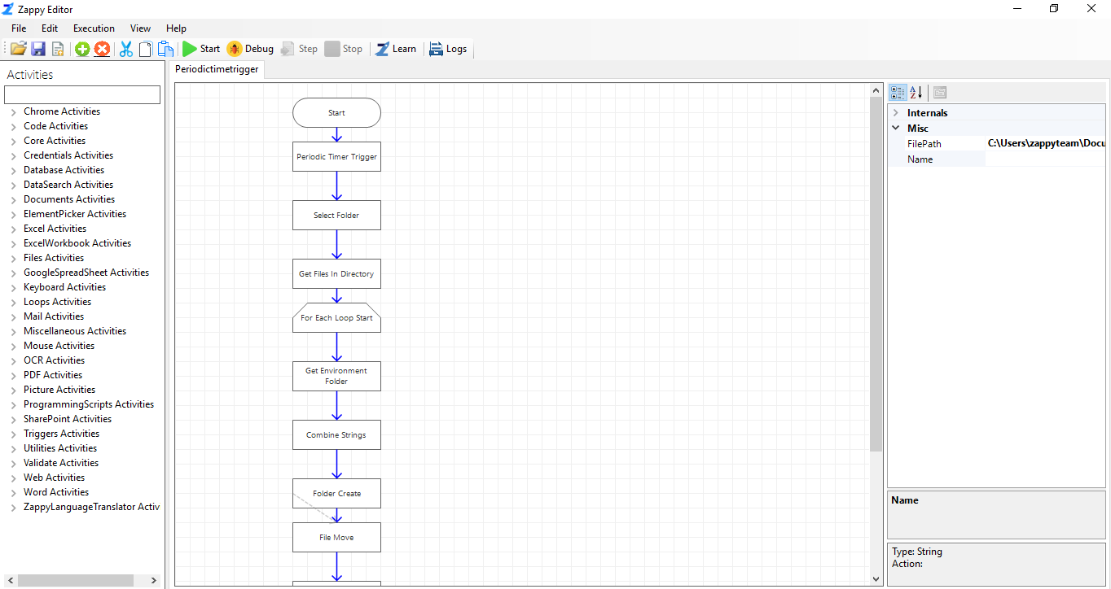

**Step 3:** Click on **Periodic Time Trigger** and set the properties.

* **DueTimeInSeconds –** Set time in Seconds. 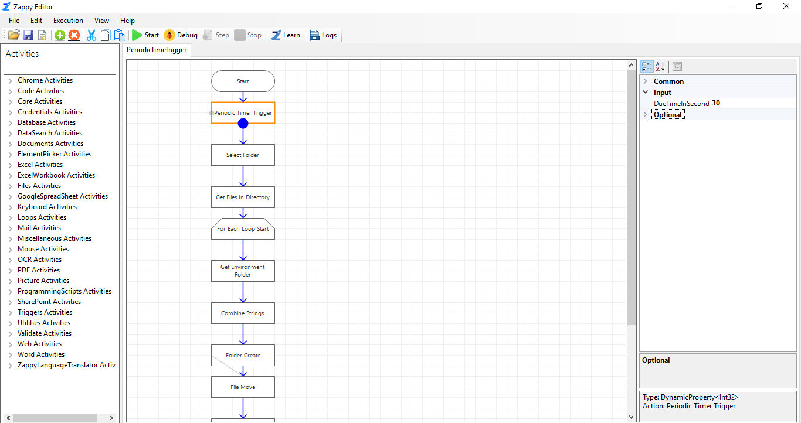

Set time for performing the task.

We can add Periodic Timer Trigger to any other automation which we want to run often.

**Step 4:** Click on **Start** button to register the trigger.

You will see the message “**Successfully Registered Active Trigger**” from Zap.

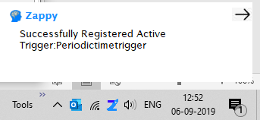

**After every 30 seconds Periodic Timer Trigger hit and move the files from source folder to destination folder**

You will see “**Successfully Executed Task**” message from Zap whenever trigger will fire.

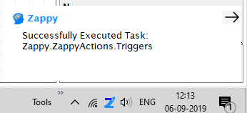

**Note:** User can see all the set triggers in, **Tools-> Trigger Manager**

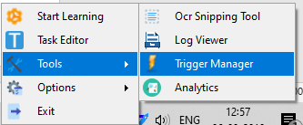

**List of all set Triggers,**

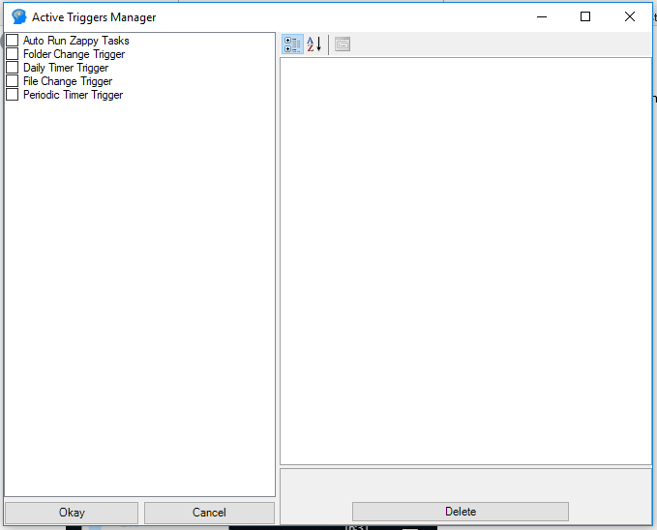

We can also delete the trigger using Active Trigger Manager